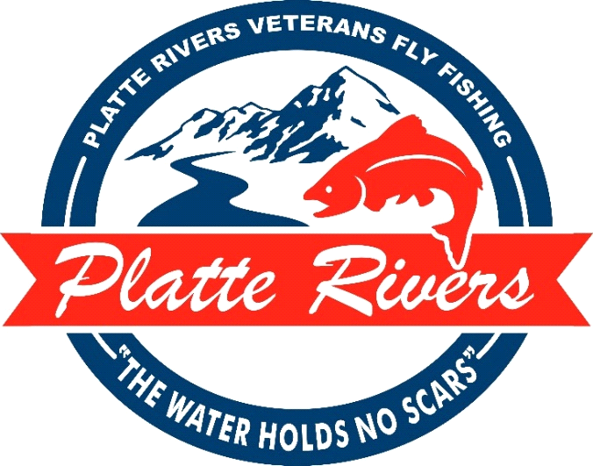

PRVFF was selected Non-Profit Organization of the Year by the Cheyenne, WY Chamber of Commerce in 2015.

Platte Rivers Veterans Fly Fishing (PRVFF) is hosting our annual fundraising banquet, Saturday, April 11th, 2026, at Red Lion Hotel and Conference Center. The evening will feature games, raffles, silent and live auction items, and a great meal. This year, PRVFF will look back at some of the successes we have experienced over the past 15 years. We have also asked a couple of our participants to share how the PRVFF programs and trips have impacted them. This will be a night of celebration, and we hope you can join us.
In the spring of 2011, PRVFF was established to assist in the readjustment and awareness of all veterans and active-duty personnel throughout the communities of Southern Wyoming, Northern Colorado, and Eastern Nebraska. This region is home to more than 450,000 Veterans who may need or have limited access to the resources necessary for successful acclimation back into the civilian world.
Educational activities and fishing trips are offered to all Veterans, usually at no cost to the individual, regardless of branch or length of service. We have served over 600 Veterans, providing fly-tying supplies, fly and rod building materials, casting instruction and all the transportation needed, meals and lodging required for our "world class" fly fishing trips. These activities are made possible through donations, sponsorships and fundraisers. PRVFF takes care and pride in ensuring all our donors know how their resources are used, and they remain local in our region of service.
Please join us on our mission to help heal the scars of the service men and women who have sacrificed so much for our us. Together we can help our Veteran community experience the excitement and healing power of Fly Fishing.

For more information please contact:

Rick Flood Larry Neasloney Greg McCoy
970-690-3491 307-631-8167 970-222-6227
“The Water Holds No Scars”

Thank you for your support of Platte Rivers Veterans Fly Fishing. Please provide the requested information for your donation. Retain the top portion of the form for your records.

Donor/copy of receipt________________________________________________________

Item Description:
__________________________________________________________________________
__________________________________________________________________________

Value:_________________________ Expiration Date (if applicable):_______________

PRVFF Representative:________________________________________________________
(Printed Name) (Signature)

If you have questions or would like to arrange for an item to be picked up, please contact:

Rick Flood Larry Neasloney Greg McCoy
970-690-3491 307-631-8167 970-222-6227

Platte Rivers Veterans Fly Fishing Tax ID #: 81-1618256

-------------------------------------------------------------------------------------------------------------------------------------------------------------

(Platte Rivers Program Copy of Receipt)

Donor:_____________________________________________________________________

Contact:_______________________________________ Phone:_________________

Email: ________________________________________

Address:___________________________________________________________________
__________________________________________________________________________

Item Description:
__________________________________________________________________________
__________________________________________________________________________
________________________________________________________________________________________________________________________________________________________________________________________________________________________________________________________________________________________________________________________________________________________________________________________________________

Value:_________________________ Expiration Date (if applicable):_______________

PRVFF Representative:________________________________________________________
(Printed Name) (Signature)
Make sure donor sheet is filled out and turned in with item.

