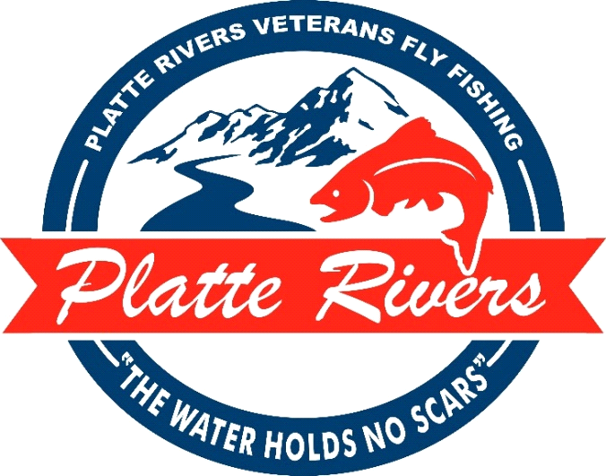

Platte Rivers Veterans Fly Fishing (PRVFF) is hosting our annual fundraising banquet, Saturday April 11th, 2026, at Red Lion Hotel and Convention Center. The evening will feature games, raffles, silent and live auction items, and a great meal. This year, we will look back at some of the successes we have experienced over the past 15 years. We have also asked a couple of our participants to share how the PRVFF programs and trips have impacted them. This will be a night of celebration, and we hope you can join us.
In the spring of 2011, PRVFF was established to assist in the readjustment and awareness of all veterans and active-duty personnel throughout the communities of Southern Wyoming and Northern Colorado. These regions are home to more than 450,000 Veterans who may need or have limited access to the resources necessary for successful acclimation back into the civilian world and deal with heal from combat related disabilities. PRVFF was selected Non-Profit Organization of the Year by the Cheyenne Chamber of Commerce in 2015.

Educational activities and fishing trips are offered to all Veterans, usually at no cost to the individual, regardless of branch or length of service. PRVFF has served well over 600 Veterans, providing fly-tying supplies, fly and rod building materials, casting instruction, transportation, meals and lodging required for our "world class" fly fishing trips. PRVFF is an all-volunteer run organization, and these activities are made possible through sponsorships, fundraising events, and your generous donations. We take care and pride in ensuring all our donors know how their resources are used and they remain local in our region of service.
Please join us on our mission to help heal the scars of the service men and women who have sacrificed so much for us. Together we can help our Veteran community experience the excitement and healing power of Fly Fishing.

For more information please contact:

Rick Flood Larry Neasloney Greg McCoy
970-690-3491 307-631-8167 970-222-6227
rflood@platterivers.org lneasloney@platterivers.org gmccoy@platterivers.org

“The Water Holds No Scars”

Over

TABLE SPONSOR OPTIONS

_______ Platinum Table Sponsor ($2500) – Includes seating for 8, Veteran-built fly rod, complimentary beer/wine, exclusive PRVFF hat and PRVFF fly box with hand-tied flies for each guest. Premium advertising includes a full-page ad in the Banquet Program, individual slide in the presentation, social media and website recognition.

_______ Gold Table Sponsor ($1250) – Includes seating for 8, Veteran-built fly rod, complimentary beer/wine. Advertising includes logo recognition in the Banquet Program and slide-show presentation, social media and website recognition.

_______ Silver Table Sponsor ($900) – Includes seating for 8.

OTHER SPONSOR OPTIONS

________ Diamond Banquet Sponsor ($1000) ________ Gold Banquet Sponsor ($250)

________ Platinum Banquet Sponsor ($500) ________ Silver Banquet Sponsor ($100)

All banquet sponsorships include logo recognition in the Banquet Program and in
the evening’s slide presentation, as well as social media and website recognition.
______________________________________________

Payment Options: ______ Pay online by credit card

______ Payment enclosed ______ Invoice Me

Please make checks payable to “PRVFF”; Platte Rivers Veterans Fly Fishing is 501c-3, Tax ID#81-1618256

Company Name:___________________________________________________________________

Contact Name:_________________________________ Email:_____________________________

Mailing Address: ________________________________________

_________________________________________

_______ Use same Ad/Logo as last year or _______ Will submit new Ad/Logo
*** Deadline for submission of Ad/Logo is March 14th, 2026 ***

Email to: Mail to: Rick Flood
gmccoy@platterivers.org Platte Valley Bank
lneasloney@platterivers.org 421 Vandehei Ave.
rflood@platterivers.org Cheyenne, WY 82009

“The Water Holds No Scars”

